GarageFlow 360 – Auto Repair Operations & Customer Retention Automation
Make.com | WhatsApp Business | Airtable/SmartSuite | Google Calendar | Google Drive | OpenAI/Claude | Gmail | Slack | Google Sheets | Webhooks

Project Overview
Built an automated workshop management system for handling customer inquiries, vehicle appointments, inspections, repair estimates, parts coordination, technician assignments, repair tracking, and customer retention.
The workflow takes a new customer inquiry and turns it into a complete repair lifecycle, from booking and vehicle check-in to estimate approval, repair completion, pickup notification, service reminders, and review follow-ups.
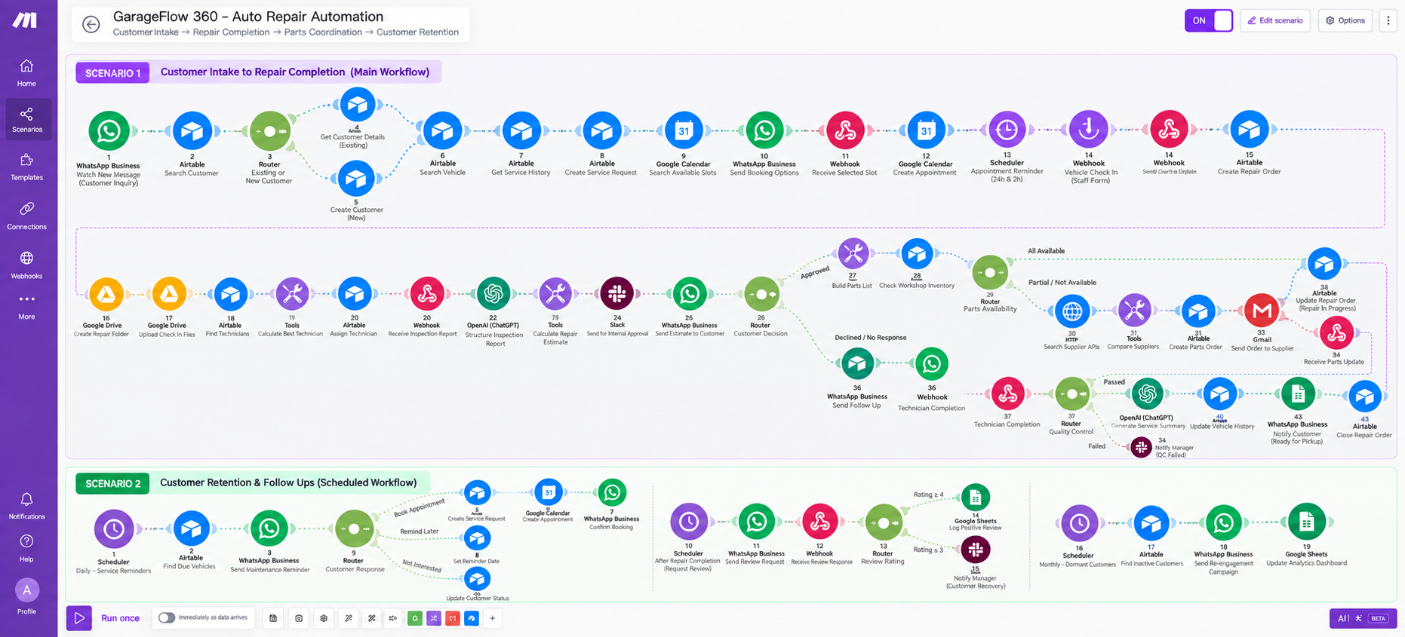
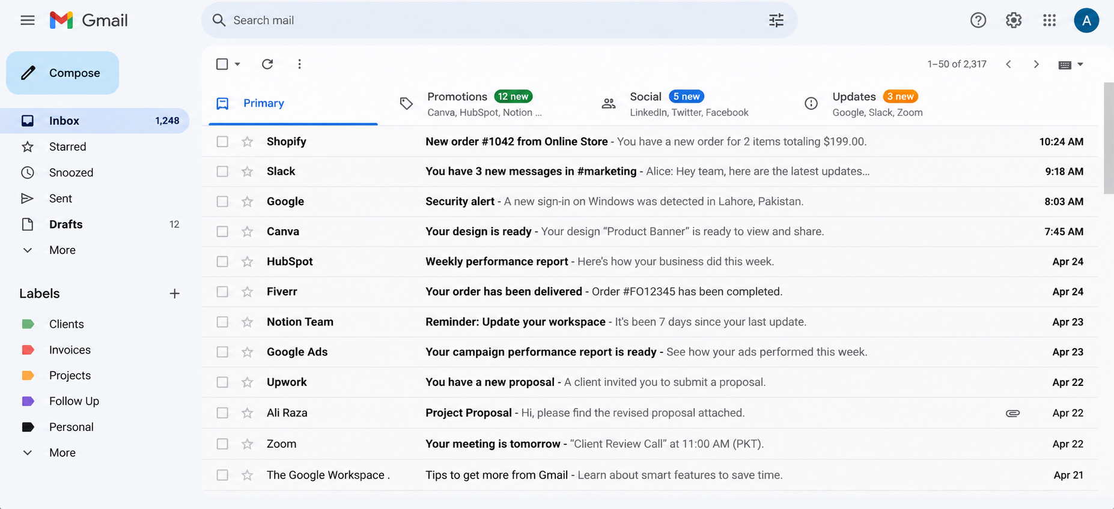
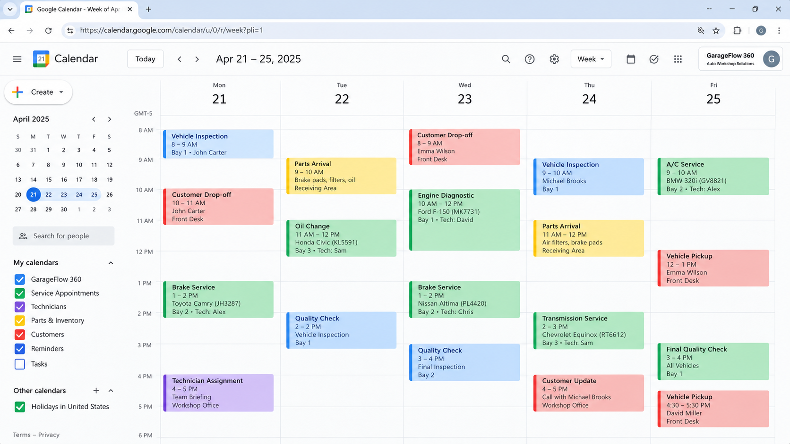
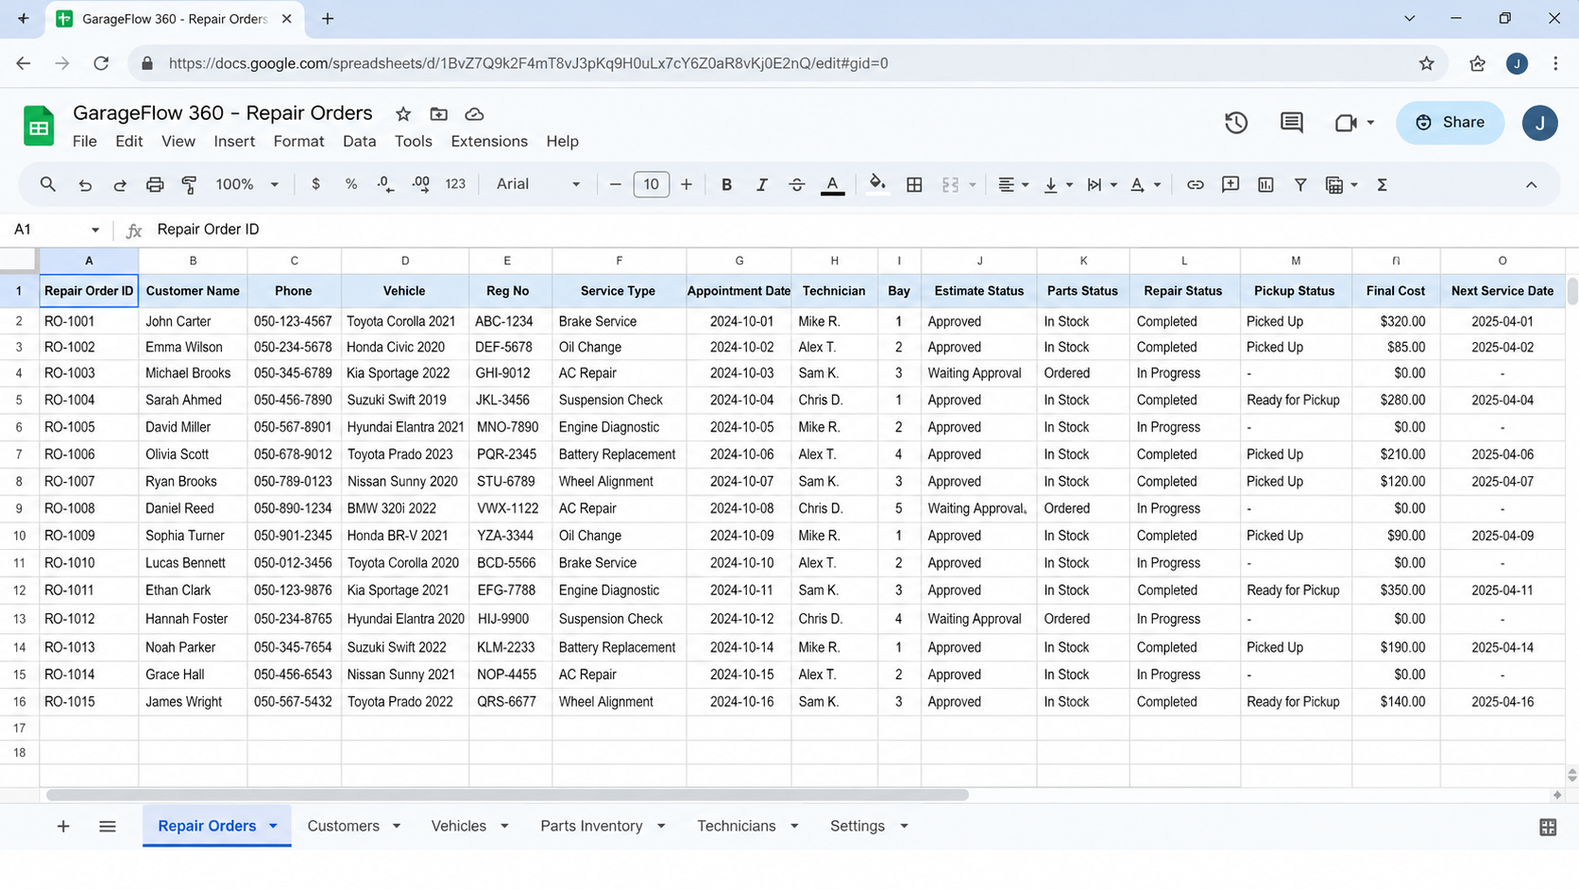

Workflow
The system:
- Receives customer inquiries through WhatsApp or website forms
- Searches existing customer and vehicle records automatically
- Retrieves previous vehicle service and repair history
- Creates new service requests and repair orders
- Checks workshop availability and sends appointment options
- Creates confirmed appointments in Google Calendar
- Sends automatic appointment reminders to customers
- Records vehicle check-in details, mileage, condition, and photos
- Creates dedicated Google Drive folders for each repair order
- Searches and assigns technicians based on skill, availability, and workload
- Processes technician inspection reports using AI
- Creates structured customer-friendly inspection summaries
- Calculates repair estimates including parts and labor
- Sends digital estimates for customer approval
- Follows up automatically when an estimate remains unanswered
- Generates required parts lists from approved repair work
- Checks workshop parts inventory before purchasing
- Searches and compares local parts suppliers when stock is unavailable
- Creates and sends supplier parts orders automatically
- Tracks delayed, partial, damaged, or incorrect parts deliveries
- Sends proactive repair-delay updates to customers
- Tracks repair progress and technician completion
- Routes completed repairs through quality control
- Generates final service summaries and repair reports
- Updates complete vehicle service history automatically
- Sends ready-for-pickup notifications through WhatsApp
- Sends future maintenance reminders and customer review requests
- Detects dormant customers for re-engagement campaigns
- Updates workshop performance analytics in Google Sheets

Branding & Templates
The workflow uses predefined workshop communication, estimate, service report, and reminder templates.
Each template controls:
- Appointment communication
- Repair estimate format
- Parts and supplier requests
- Customer repair updates
- Service reminders
This keeps workshop communication consistent across customers, vehicles, technicians, and repair orders.

Content Management
Airtable or SmartSuite acts as the central customer, vehicle, repair order, technician, and parts tracking system.
Each repair order is updated with:
- Customer information
- Vehicle details
- Technician assignment
- Estimate status
- Parts status
- Repair status
- Pickup status
- Final cost
- Next service date

Technology
- Make.com
- WhatsApp Business
- Airtable/SmartSuite
- Google Calendar
- Google Drive
- OpenAI/Claude
- Gmail
- Slack
- Google Sheets
- Webhooks

Result
A complete automated auto repair workflow that turns a customer inquiry into an appointed, inspected, approved, repaired, documented, and completed vehicle service without requiring workshop staff to manually coordinate every step.
The system also keeps customer records, vehicle history, repair estimates, parts orders, technician activity, service reminders, reviews, and workshop analytics organized in one workflow.

